**Exercise 1**

The following *sudo./discover.sh* was completed on the *REPUBLICOFKOFFEE.COM* server. The entire contents have been zipped and submitted.

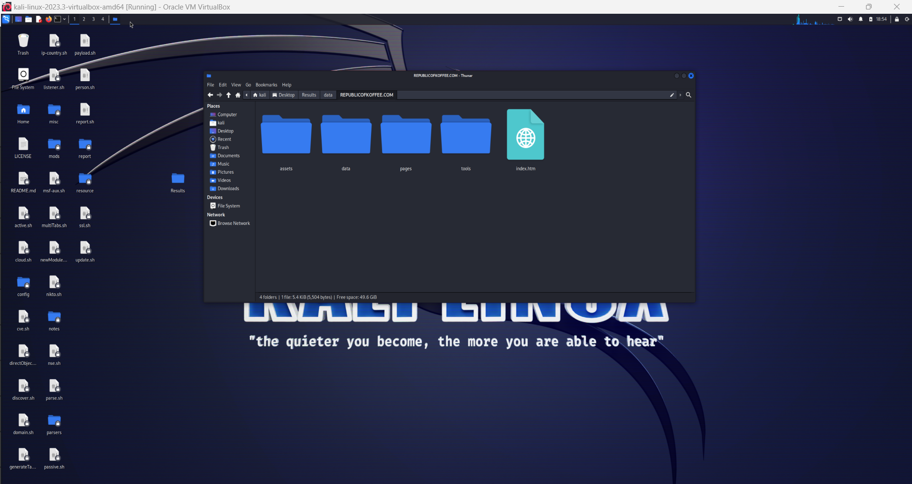

**Exercise 2**

**1. Who owns the domain?**

NameCheap, Inc.

**2. When was it created (date and time)?**

2021-01-01T17:33:07Z

**3. What is the second name server associated with this domain?**

ns2.brainydns.COM

**4. What is the name of [the] registrant, if available?**

NameCheap, Inc. - More detail is protected by withheldforprivacy.com

**5. What is the country of the registrant?**

Iceland (Reykjavik)

**6. Use the waybackmachine Internet archive to find the name of the author of the very first blog that was written on this website.**

“Steve”: Reviewed March 14, 2015